|  |  |
| --- | --- |
| Course Name | ITD 2313 – Script Programming |
| Instructor | Michael Schnell |
| Student Name | Samantha Ramsey |
| Due date | 3/5/2023 |
| Grade | Put grade earned here |
| Grading Comments | Put instructor comments here |

# A quick review of what functions are and how they work

## Functions Eliminate Redundancy

### Page 169

1. There is an example at the bottom of the page with a function and it being used a few times.  The code example block does end on the end of the page.

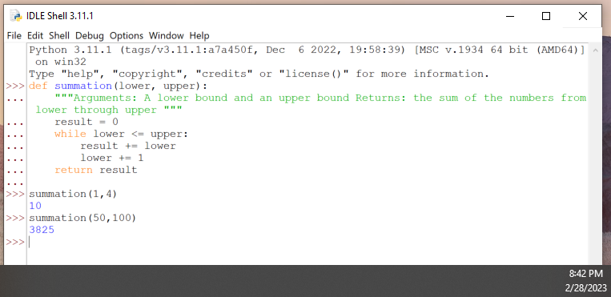

There are many pages of reading between the first and second instructions in this assignment.  Do not just skim them.  Read them pretty well.  Functions and related topics are very important.

# Design with Recursive Functions

## Defining a Recursive Function

### Page 176

1. About 2/3 ways down, the first code example block on this page is not a recursive function but should be done.  You will need to add the code to execute the function though.

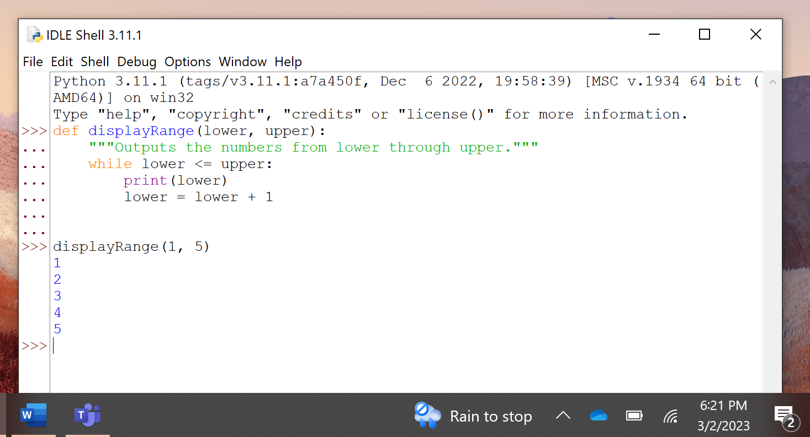

1. The last code example block which is at the bottom, is a recursive function.  You will again need to add the code to execute the function.

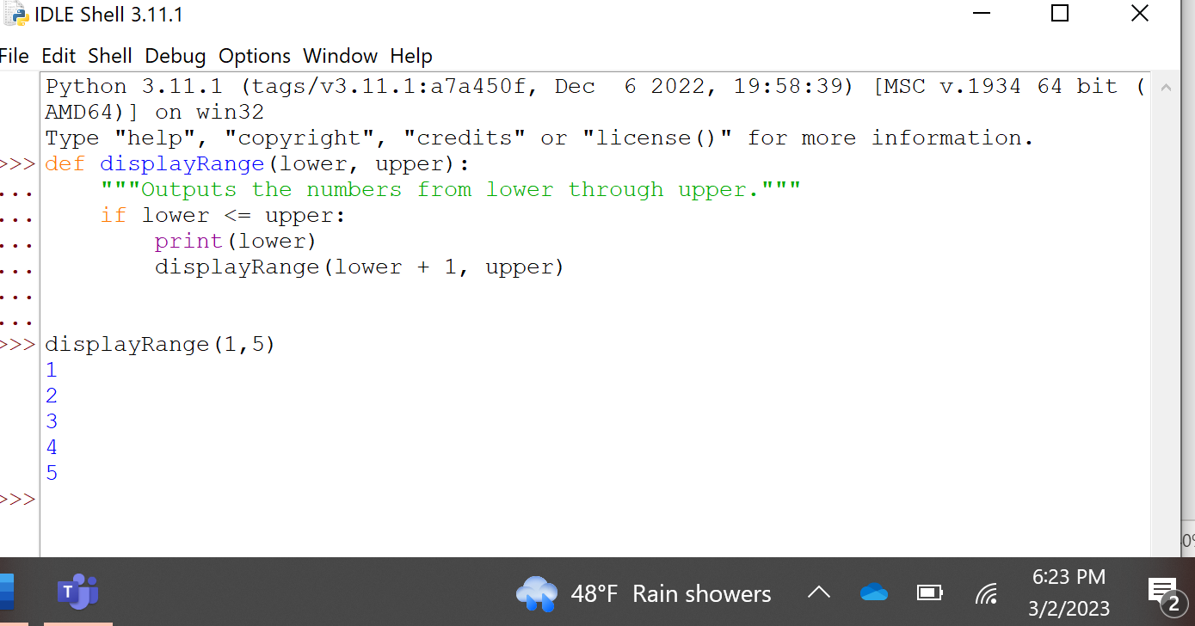

### Page 177

1. In the middle of the page is another recursive code example block. You will need to add in the execute code on this one also.

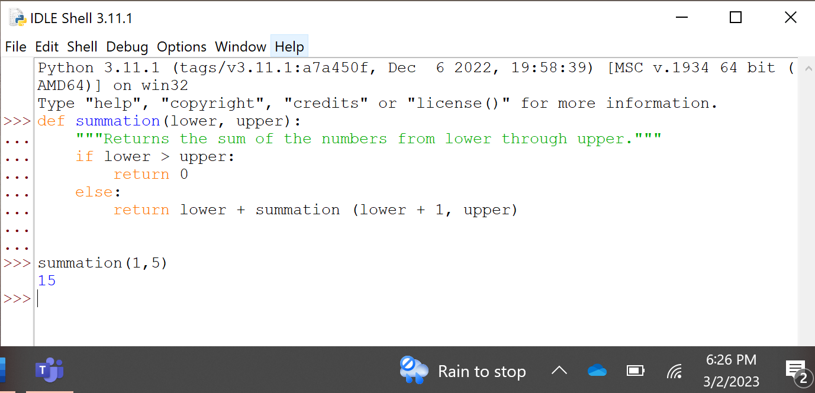

1. The code example block on the bottom of the page spills onto the next page.  The screen shots for that one will go on that page.

## Tracing a Recursive Function

### Page 178

1. The code example block that end on the top of the page started on the bottom of the previous page.  Put the screen shot here for that code example block.

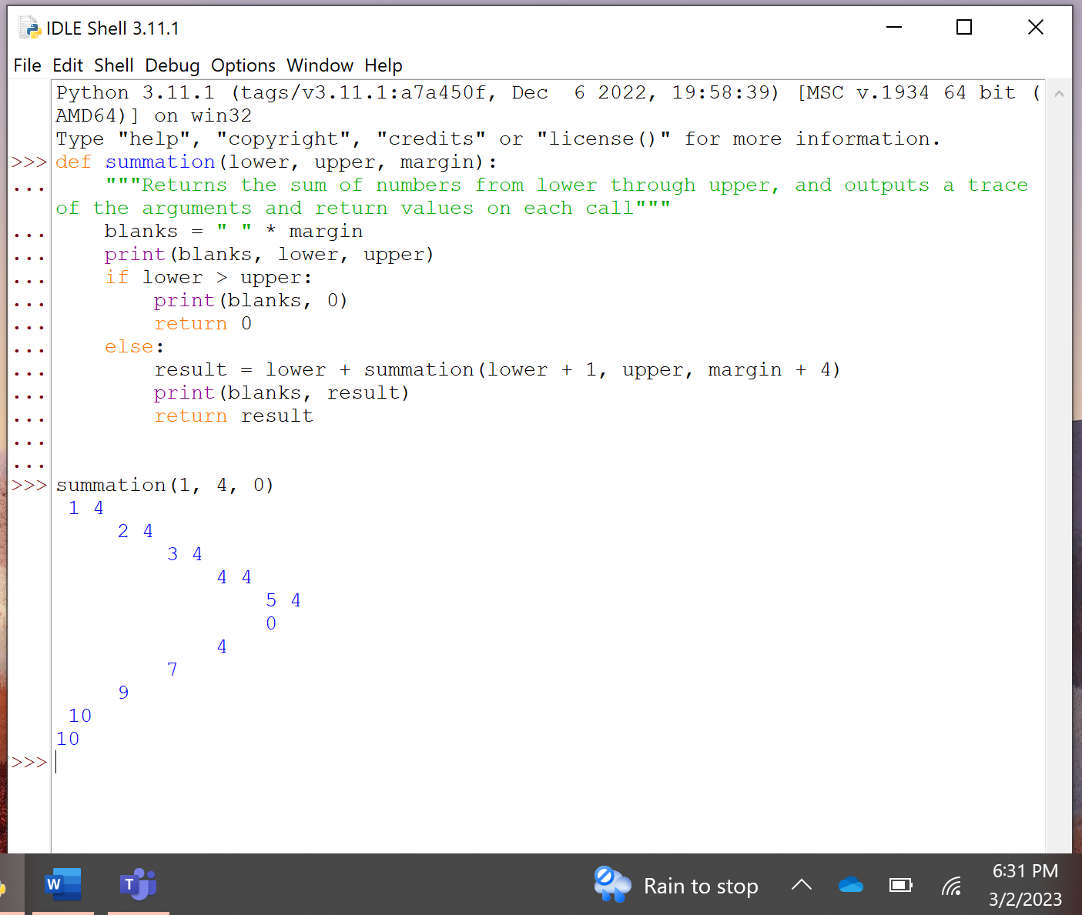

1. At the bottom of the page is another recursive function in a new subsection.  You will need to add in the code to execute that function also.

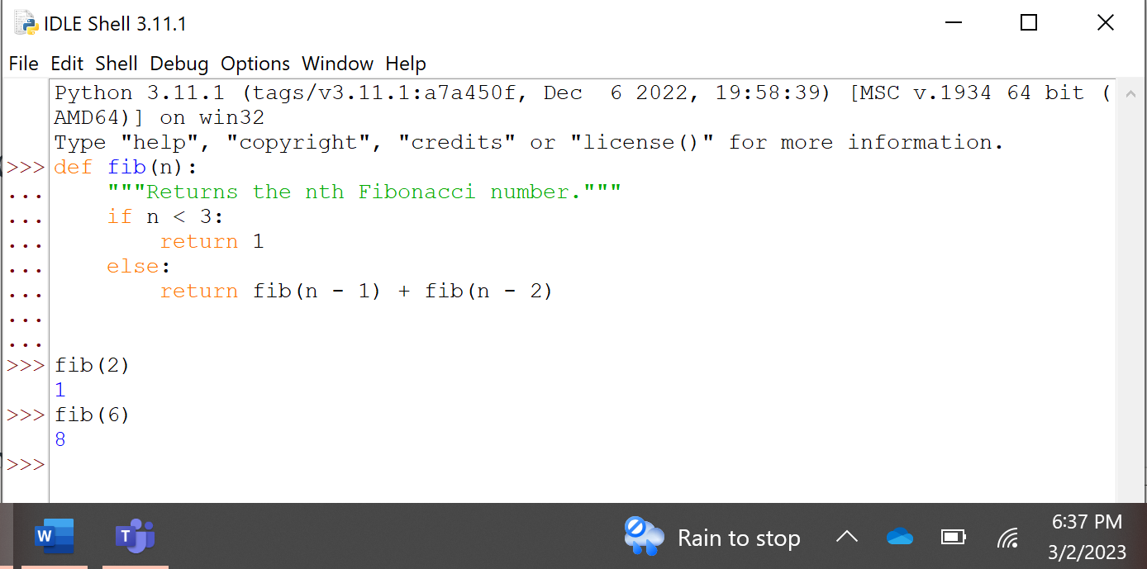

## Recursive Sentence Structure

### Page 179

1. The code for some items for this is not there.  This is more a theoretical example.  So do not try and make screenshots on it.

## Infinite Recursion

### Page 180

1. Yes, there is a code example block of infinite recursion. It will cause an error.  You are to do the code example block and capture the resulting error.

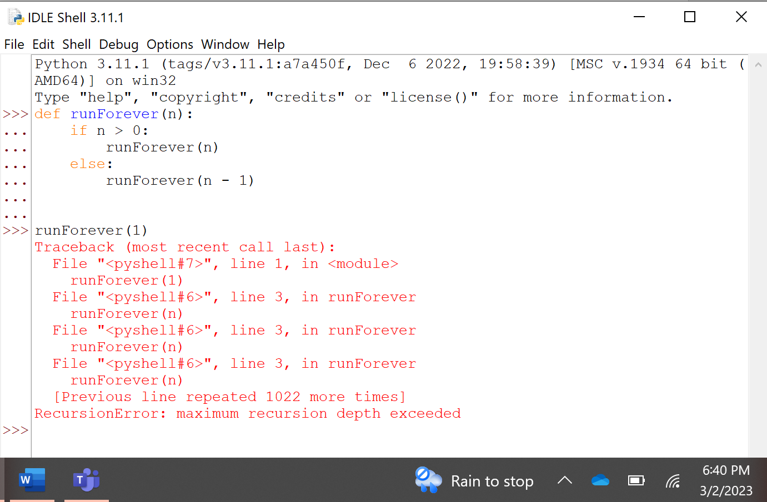

You do not have to do the Case Study about file systems coding for this exercise. You should read through it and maybe even try the code on your own for learning opportunities.